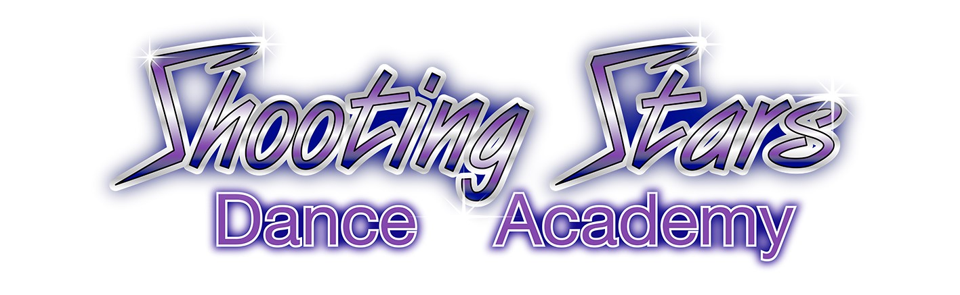
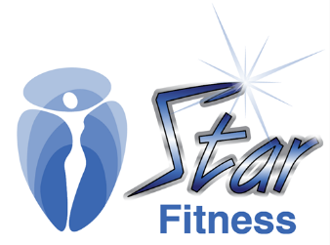
Shooting Stars Dance Academy / Star Fitness (SSDA)
CHILD SAFE POLICY
(13 July 2021)

- Introduction
Our Policy guides staff, contractors and volunteers on how to behave with children in our service. This Policy focuses on how we can make our dance and fitness studio safer for them.

- Support for children’s participation
SSDA supports the active participation of children in our service. We listen to children’s views and respect what they say.

- Recruitment
- Our service will maintain a rigorous and consistent recruitment, screening and selection process for staff, contractors and volunteers.
- We will ensure all staff, contractors and volunteers have a Working With Children Check, and have at least 2 references (personal and/or work) who are checked via phone. We will promote our Code of Conduct upon inducting new staff.

- Complaints
- Our studio has appointed the Principal as the Child Safety Contact Person to manage all complaints. Children, families, staff, contractors and volunteers can raise complaints about child-safe practices by approaching the Principal, Ms Selena Atalla (0416 035 554 or selena@shootingstarsdance.com.au).
- Where there are any concerns about the Principal, the alternate Child Safety Contact Person is Admin, Ms Cherry Siu-Ho (0424 188 525 or cherry@shootingstarsdance.com.au)
- Where children, their families, or any staff, contractor or volunteer wishes to raise a complaint, the Child Safety Contact Person will document the complaint and raise the issue with the relevant people concerned where appropriate.
- The Child Safety Contact Person will ensure that all complaints are investigated in a timely, transparent, thorough and impartial manner, and that affected parties are advised of the outcome and their rights of appeal.
- Where SSDA suspects, on reasonable grounds, that a child or young person is at risk of being neglected or physically, sexually or emotionally abused, it will report it to NSW Department of Family and Community Services (FACS). Reports will be made by phoning the Child Protection Helpline on 132 111.
- NSW Police will be contacted in appropriate circumstances.

- Support and supervision for staff, contractors and volunteers
- We promote respect, fairness and consideration for all staff, contractors and volunteers.
- All staff, contractors and volunteers can access the Principal to support and supervise their work.
- All new staff, volunteers and students will receive a copy of the Child Safe Policy and Code of Conduct.
- Children and families joining our studio will be made aware of the Child Safe Policy, Code of Conduct and Complaints process.
- We will educate our staff, contractors and volunteers on child abuse awareness, physical contact principles, age-appropriate practices and anti-bullying principles.
- Physical contact with a child and young person should be used: only for correctional purposes, with prior consent, and openly in front of other students. Physical contact in choreography between children and young people should occur only in choreography when necessary e.g. lifts, partnering; with prior consent; and openly in front of other students and instructors. Students will always have the ability to opt out of performing choreography which includes physical contact with other dancers.
- Physical contact may be required if first aid needs to be administered.
- Classes will be conducted wherever possible at our studio premises in Picton with viewing windows.
- SSDA is committed to providing age-appropriate programs, activities and services that do not sexualise children and young people. SSDA promotes age-appropriate behaviour through the use of: age-appropriate music, uniforms and costumes, choreography/dance moves, stage make-up (worn at performances only).
- SSDA does not accept any bullying of children and young people by any party. SSDA acknowledges that bullying can take place on the premises and also off site through electronic communication such as social media. SSDA does not tolerate bullying of any kind and will take action to rectify any reported bullying including taking legal action if necessary.

- Communication
- We will make relevant information readily available for staff, contractors, volunteers and students.
- Our policy will be discussed during induction sessions for all new staff, contractors and volunteers.
- All new families will be made aware of the Policy, Code of Conduct and Complaints process.

- Guiding References
In developing the Child Safe Policy, SSDA has been guided by the following:
- UN Convention on the Rights of the Child
- The Child Protection (Working with Children) Act 2012
- The Child Protection (Working with Children) Regulation 2013
- Children and Young Persons (Care & Protection) Act 1998
- Commission for Children and Young People Act 1998
- Children and Young Persons (Care and Protection)(Child Employment) Regulation 2015 Guiding Documents/Website
- Ausdance Child Protection Factsheet 21

- Review
This Policy will be reviewed every two years and incorporate comments and suggestions from children, families, staff, contractors, volunteers and students.

