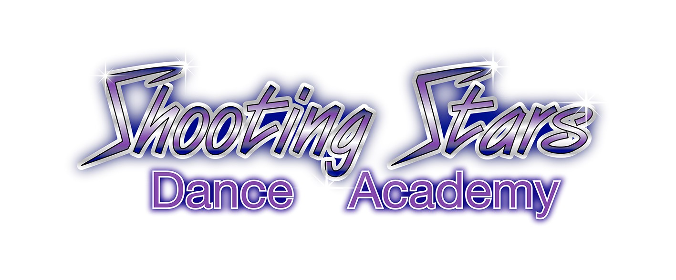
TERMS & CONDITIONS
(21 July 2019)

These are the terms and conditions upon which Shooting Stars Dance Academy Pty Ltd (‘SSDA’) provides dance tuition and related services (‘Services’). In these terms and conditions, the terms ‘You’ and ‘Your’ means the student/student's parent or guardian.
- Enrolment
  - An Enrolment Form must be completed to ensure a place in a class. By signing the Enrolment Form (either online or hardcopy), You agree to SSDA policies and these Terms & Conditions.
  - The Class Timetable and Pricing is subject to change every term, and it is Your responsibility to check that any updated class information and pricing is acceptable to You prior to continuing with enrolment for the relevant term.

- Fitness to Participate
  - SSDA provides the Services on the assumption that a student is fit to participate and receive the Services, unless the Principal is otherwise informed via the Enrolment Form or by other means.
  - By continuing to be enrolled and attending class, You represent that the Student is fit to participate and receive the Services.

- Studio Conduct
  - SSDA takes no responsibility for students or their family members whilst outside the studio. Responsibility for students outside the studio lies with the student’s parent or guardian. Students will not be released from class until a parent or guardian is seen by the teacher.
  - Students should be appropriately attired in accordance with the Uniform Policy, and bring water and suitable refreshments with them to class.
  - Parents and guardians are liable for any damage to the studio and studio contents caused by their children.

- Lost Property
No responsibility will be taken for personal property. You should label all clothing and shoes to enable SSDA to return to the correct owner. At the end of the term, any unclaimed property will be given to charity.

- Appropriate Behaviours
  - SSDA will not tolerate the following forms of unacceptable behaviour:
    - verbal or physical abuse;
    - intimidation by a student, parent or guardian;
    - discrimination in all its forms as defined under the Anti-Discrimination Act 1977 (NSW);
    - harassment or threats of any nature towards students, parents and guardians, or any staff or volunteers or third parties attending SSDA
  - The behaviours described in clause 5.1 above extends to those behaviours occurring at any location attended by SSDA and during any SSDA performances.

- Cancellation of Enrolment by SSDA
  - Your enrolment in SSDA will be cancelled where any of the following occurs:
    - while any of our invoices remain unpaid for over 30 days of the due date on the invoice;
    - if You fail to comply with any reasonable direction issued by any staff member of SSDA which compromises our ability to provide our Services to students or compromises the safety and welfare of other students;
    - for any other reason outside our control which has the effect of compromising our ability to perform the Services within the required timeframe;
    - if in our sole discretion, SSDA considers it is no longer appropriate to provide the Services to You.
- Payment of Fees
  - SSDA operates on four (4) terms in each year in accordance with NSW public school terms, available at https://education.nsw.gov.au/public-schools/going-to-a-public-school/calendars.
  - SSDA’s first day of term is generally on a Monday unless it falls on a public holiday.
  - Term fees are payable for a term in advance and are due in accordance with the due date on each term’s invoice.
  - Per class fees are payable at the commencement of each class in cash.
  - Unless required by law, fees are non-refundable once paid, and there are no refunds for discontinuing once a term has commenced or for lessons that fall on a public holiday.
  - Make-up lessons for non-attendance or for lessons that fall on a public holiday may be available at the Principal’s discretion.
  - All costumes for performances are payable once ordering has commenced.
  - If any fees are unpaid for a period in excess of 30 days from the due date of the invoice, SSDA has the right to: (a) exclude the student from attending classes and cancel enrolment and/or (b) take debt recovery proceedings. Please speak to the Principal if you are having difficulties with making Your payment.

- Where SSDA Cancels a Class
Where SSDA cancels a class for any reason, SSDA in its sole discretion will decide whether it is appropriate to offer a make-up lesson or provide a refund as an alternative.
- Personal Injury and Physical Contact
  - By enrolling in SSDA, you accept that all dance classes, activities and events held at SSDA studios can involve the risk of personal injury. SSDA accepts no responsibility or legal liability arising from Your participation or attendance in SSDA dance classes or other events. You agree to release SSDA from all liability to the full extent permitted by law for any personal injury sustained by a student as a result of any negligent or deliberate act or omission sustained whilst on our premises including the studio.
  - Demonstration of exercises and personal correction requires some physical contact from time-to-time in order to assist understanding of movement.
  - Physical contact may be required if first aid needs to be administered.

- Prohibition on Photographs and Video Recordings
  - Out of respect for students and teaching staff, You are not permitted to photograph or video record of any classes or student performances unless they occur in a public space.
  - Where You fail to comply with clause 10.1, SSDA may require deletion of the recording and if not complied with, the enrolment of the student may be cancelled and You will not be permitted to attend SSDA premises or attend any performance of SSDA.
  - Where in SSDA’s view, a breach of clause 10.1 may involve criminal conduct, SSDA reserves its right to inform law enforcement.
  - You release SSDA, its staff and volunteers from any claim, writ, or suit that You may be seeking to bring against SSDA, as a result of SSDA making a report as specified in clause 10.3.

- Email and Online Content
  - SSDA may from time to time exchange electronic mail with You. However, as such mail is not secure, it may be copied, recorded, read or interfered with by third parties while in transit. You release us from any claim You may have as a result of any unauthorised copying, recording, reading or interference with that communication, for any delay or non-delivery of any communication, and for any damage caused to Your system or any files by a transfer.
  - Whilst every attempt will be made to ensure that SSDA’s website and social media content is appropriate and relevant, such pages may contain links to pages maintained by other organisations, or comments made by other individuals and organisations, over which SSDA has no control. SSDA does not necessarily sponsor, endorse or approve such material on external sites, or the operations of external sites, or the views and comments on such pages.
  - All copyright in SSDA content on SSDA’s website and social media pages and downloads from such pages are owned by SSDA, except for any third party copyright included under licence or agreement.

- Staff and Volunteer Code of Conduct
  - SSDA may from time to time employ or engage employees and volunteers for teaching and administrative roles.
  - SSDA aims to ensure that all SSDA representatives will at all times conduct themselves in an ethical manner and strive to make all interactions with You positive, inclusive, respectful and productive.
  - All SSDA staff and volunteers are expected to fulfill all of the following:
    - carry out their work efficiently, lawfully, economically and effectively, and operate in a professional and respectful manner, adhering to all SSDA legal obligations, policies and these Terms & Conditions;
    - act ethically, honestly and exercise diligence in all studio operations, which includes not acquiring any personal profit or advantage through their involvement with SSDA;
    - carry out all lawful directions;
    - identify and manage conflicts of interests appropriately in consultation with the Principal;
    - report suspected breaches of legal obligations, policies and Terms & Conditions;
    - ensure SSDA activities and environments are safe for children;
    - hold a current Working with Children Check registration, or obtain one prior to commencing in a SSDA role.

- Privacy policy
  - In accordance with the Australian Privacy Principles, SSDA recognises that every individual has the right to ensure that their personal information is accurate, secure and only used, disclosed and stored for the purposes for which it was originally collected.
  - SSDA collects personal information as necessary to carry out studio operations, for marketing and promotions, or to comply with legal obligations.
  - During the enrolment process, SSDA will collect personal information from You via the Enrolment Form, such as name, address, email, phone number, date of birth, age, family contact details, medical information and information about siblings at the studio.
  - During the enrolment process, SSDA will advise that the Terms and Conditions including this Privacy Policy are available on SSDA’s website.
  - SSDA may also collect personal information verbally during class attendance, or through our website and social media pages.
  - By enrolling, You agree for SSDA to use, disclose and store Your personal information for the purposes of Your enrolment, class participation and ongoing engagement with SSDA and its activities.
  - By enrolling, You agree to receive newsletters and communications from SSDA including marketing and promotional material, and You can opt-out at any time by giving notice to the Principal.
- Photography and Video Recording by SSDA
  - You grant SSDA the right to photograph and take video recordings of You in classes, rehearsals, performances, and in costumes and for SSDA to own the copyright in such recordings and use them for SSDA’s teaching purposes, and for marketing and publicity materials, including displaying on websites and social media.
  - You may opt-out of this by giving notice to the Principal.

- Complaints Handling
  - All breaches of these Terms & Conditions and SSDA Policies will be managed in line with this clause.
  - Where You or a SSDA staff member or volunteer wishes to raise a complaint concerning a student, parent or guardian, or a SSDA staff member or volunteer, the Principal will document the complaint and raise the issue with the relevant people concerned where appropriate, and seek to resolve the issue via confidential and respectful discussion.
  - The Principal will ensure that all complaints are investigated in a timely, transparent, thorough and impartial manner, and that affected parties are advised of the outcome and their rights of appeal.
  - For all fee complaints, You are required to contact the Principal as soon as possible.
- Indemnity
You indemnify SSDA, its employees and agents against any liability, loss or damage (including but not limited to for any personal injury, property damage/loss or wrongful death), costs (including the costs of any settlement and legal costs and expenses on a solicitor and own client basis) and expenses arising out of or in connection with a wilful default or unlawful or negligent act or omission by You.

- Changes to Terms & Conditions and Policies
SSDA may, at its sole discretion, change its policies and Terms and Conditions at any time, and will use reasonable endeavours to inform You of any substantial changes, which may include announcing the fact of changes via social media, email or in person at the studio. However, it is advised that You periodically review these Terms & Conditions and policies on the SSDA website.

- Applicable Law
These Terms & Conditions are made pursuant to the laws of New South Wales.

